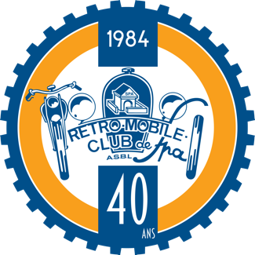
Sunday 25 august 2024 – Concours d’élégance

REGISTRATION FORM

To be returned as soon as possible to the Rétromobile Club de Spa and by 1 August 2024 at the latest
Bd des Guérêts 53, 4900 - SPA Belgium, or by e-mail: secretariat@retromobileclubdespa.be

PARTICIPANT
Surname : .............................................................................Fisrt Name : ........................................................

Adress : Street............................................................................................................................no...........

Postcode : .......... ............City : ......................................................

Mobile phone number. : …...................................................e-mail : ………………………………

Club with wich I participate : .................................................................................................

VEHICLE (built up to 2004) Customs, replicas and copies are not accepted

Make: .......................................................Type :.....................................................Year :...................

Power (hp).................................. cubic capacity (cc)........................Colour.................................................

Restored vehicle : yes/no. vehicle in original condition : yes/no.

specific features: ..........................................................................................................................................................................
………………………………………………………………………………………………………………….………………………………………………………………………………………………………………………………………………………………………………………………………………………

attach a recent picture of the vehicle involved
Rules for the Concours d'Elegance appended

Date et signature,

CONCOURS D'ÉLÉGANCE

30 vehicles will be selected to take part in the Concours d'Elegance on Sunday 25 August 2024 from 1.30 p.m.

A pre-selection will be made on the basis of the most distinctive and/or prestigious vehicles in each category.

Entries must be sent to the Rétromobile Club de Spa, Bd des Guérêts, 53, 4900 SPA or by e-mail to secretariat@retromobileclubdespa.be, together with the entry form and a photo of the vehicle
by 1 August 2024 at the latest.

Each shortlisted participant will be notified before 10 August 2024.

The vehicles are expected to arrive on the morning of Sunday 25 August 2024 between 8 and 9.30 a.m. at Place du Monument in Spa.

Crews must remain close to their vehicle until the jury has passed.
The concours will start at 1.30pm.

- Teams are strongly advised to dress in period costume to match their vehicle - Teams are strongly advised to dress in period costume to match their vehicle.

- Candidates must provide the characteristics and history of the vehicle presented and the scenario envisaged for their show, by 14 August 2024 at the latest, in order to be used for the presentation of the vehicle and the crew when they appear before the jury and are presented at the concours d'élégance.

Vehicles will be classified and presented by category:
- Vehicles built before 1945
- Vehicles built from 1946 to 1970
- Vehicles built from 1971 to 1994
- Youngtimers from 1995 to 2004

A classification by category will be established: two marks will be awarded by each member of the jury.
The first mark will reward the model, the state of presentation and restoration of the vehicle.
The second mark will be awarded for the performance of the crew (respect for period dress).

A third note will concern the show. The show is limited to a maximum of 3 minutes - the show is not compulsory but is highly recommended.

There will be a special prize for the best show in each category and a super prize for the best show in all categories.

The vehicle with the most points in all categories will receive the top prize.

For the super prizes, and in the event of a tie, the age of the oldest vehicle will prevail.

Any points not covered will be decided by the jury, and all decisions will be final.

